**

5/12/2025

te

**Prepared by: Amr Mohamed Zohier**

**Supervised by: Prof. Ahmed Magdy**

**Dr. Iman Mostafa**

**Exchange Rate Prediction with PSO-Optimized Neural Networks**

**Technical Report**

**1. Introduction to the Selected Problem**

Foreign exchange rate prediction represents one of the most challenging problems in financial forecasting due to the complex, non-linear, and often chaotic nature of currency markets. Traditional statistical methods frequently fail to capture the intricate patterns and relationships that drive exchange rate movements. This report focuses on predicting the GBP/USD exchange rate using advanced neural network architectures optimized through Particle Swarm Optimization (PSO).

The foreign exchange market is influenced by numerous factors including economic indicators, interest rates, political events, and market sentiment. The GBP/USD pair has shown significant volatility in recent years due to events such as Brexit and global economic uncertainties, making it an ideal candidate for testing advanced prediction methodologies.

**2. Objectives**

**The primary objectives of this research are:**

1. To develop accurate neural network models for predicting the GBP/USD exchange rate
2. To implement and evaluate both Multilayer Perceptron (MLP) and Convolutional Neural Network (CNN) architectures
3. To optimize these models using Particle Swarm Optimization for hyperparameter tuning
4. To compare the performance of traditional and PSO-optimized models
5. To assess the effectiveness of univariate approaches in exchange rate prediction

**3. Mathematical Modeling**

**Data Preprocessing and Feature Engineering**

The time series data is transformed into a supervised learning problem using lagged sequences. For a time, series $X = \{x₁, x₂, ..., xₙ\},$ and a lag value of k, we create:

* Input sequences: $\{x₁, x₂, ..., xₖ\}, \{x₂, x₃, ..., xₖ₊₁\}, ..., \{xₙ₋ₖ, xₙ₋ₖ₊₁, ..., xₙ₋₁\}$
* Output values: $xₖ₊₁, xₖ₊₂, ..., xₙ$

**Objective Function**

The primary objective function is to minimize the Root Mean Square Error (RMSE) between predicted and actual exchange rates:

RMSE = $\sqrt{(\frac{1}{n} ∑ (yᵢ - ŷᵢ) ²)}$

**Where:**

* $n$ is the number of test samples
* $yᵢ$ is the actual exchange rate
* $ŷᵢ$ is the predicted exchange rate

**Constraints**

**Optimization is subject to the following constraints:**

1. Neural network hyperparameters must be within defined search spaces
2. Model complexity must be balanced against computational efficiency
3. The model must generalize well to unseen data (avoid overfitting)

**4. Optimization Method Used**

**Particle Swarm Optimization (PSO)**

PSO is a population-based stochastic optimization technique inspired by the social behavior of birds flocking or fish schooling. In PSO, potential solutions (particles) move through the problem space following the current optimum particles.

The algorithm maintains a population of particles, each representing a potential solution (set of hyperparameters).

**Each particle has:**

* A position vector (current solution)
* A velocity vector (direction of movement)
* A personal best position (best solution found by the particle)
* A global best position (best solution found by any particle)

**The position and velocity update equations are:**

$v_{i}^{t+1}=w.v_{i}^{t}$ + $c_{1}.r_{1}$.($p_{i}-x_{i}^{t})+c_{2}.r_{2}.(g-x_{i}^{t})$

$$x_{i}^{t+1}{=x}_{i}^{t}+v_{i}^{t+1}$$

**Where**:

* $x_{i}(t)$ is the current position of particle $i$ at time $t$
* $v_{i}(t)$ is the current velocity of particle $i$ at time $t$
* $w$ is the inertia weight
* $c_{1}$ and $c_{2}$ are acceleration coefficients
* $r_{1}$ and $r_{2}$ are random values in the range [0,1]
* $p_{i}$ is the personal best position of particle $i$
* $g$ is the best global position of the swarm

The PSO algorithm was implemented to optimize the following hyperparameters:

* Number of layers and neurons per layer
* Learning rate
* Batch size
* Activation functions
* Kernel size (for CNN)
* Number of filters (for CNN)

**5. Results and Interpretation**

The models were evaluated using RMSE on the test dataset. The results show significant improvements in the PSO-optimized models compared to the baseline models:

| **Model** | **RMSE** | **Improvement** |
| --- | --- | --- |
| Original MLP Univariate | 0.01295 | - |
| PSO-Optimized MLP Univariate | 0.00708 | 45.33% |
| Original CNN Univariate | 0.03028 | - |
| PSO-Optimized CNN Univariate | 0.00654 | 78.40% |

**Training and Validation Loss**

The following figures show the training and validation loss curves for the MLP and CNN models:

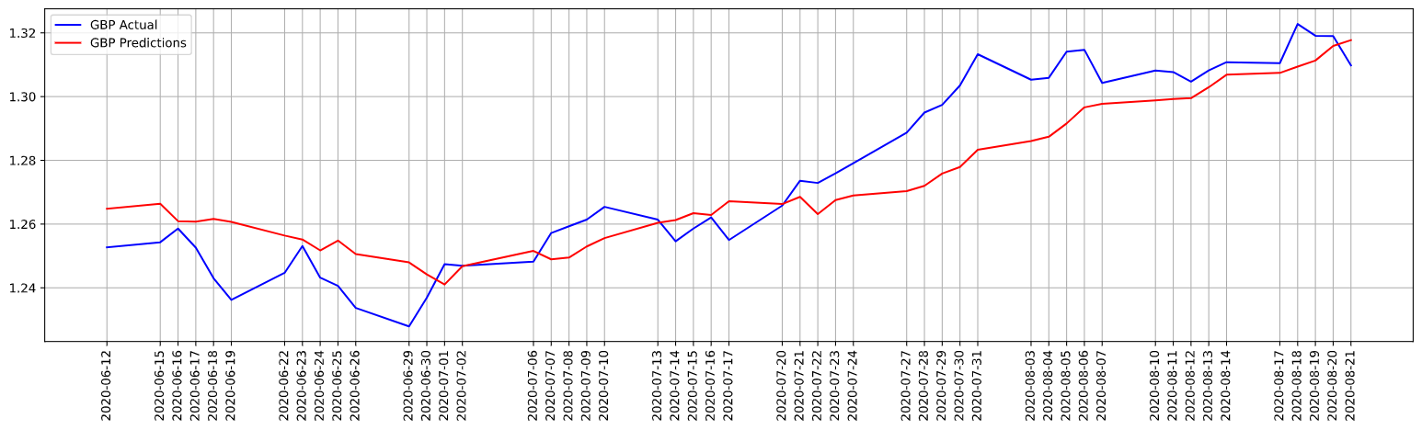

Figure 1: Actual and Prediction loss for the MLP model

Figure 2: Actual and Prediction loss for the CNN model

**Prediction Performance**

Figure 3 compare the actual GBP/USD exchange rates with the predictions from the baseline and PSO-optimized models:

Figure 3: Comparison of actual vs. predicted values for MLP models

Figure 4: Comparison of actual vs. predicted values for CNN models

The PSO-optimized models achieved better performance with more efficient architecture, demonstrating the effectiveness of the optimization approach.

**6. Discussion and Future Improvements**

**Key Findings**

1. PSO significantly improves neural network performance for exchange rate prediction
2. CNNs outperform MLPs when optimized, suggesting their ability to better capture temporal patterns
3. The univariate approach (using only historical exchange rates) provides surprisingly good results

**Model Performance Comparison**

The following figure compares the RMSE values of all models, highlighting the improvements achieved through PSO optimization:

Figure 5: RMSE comparison between baseline and PSO-optimized models

**Limitations**

1. The models only consider the GBP/USD pair and may not generalize to other currency pairs
2. The training period may not capture all possible market conditions
3. The univariate approach ignores potentially valuable exogenous variables

**Future Improvements**

1. **Multivariate Models**: Incorporate additional economic indicators such as interest rates, GDP, and inflation
2. **Hybrid Models**: Combine neural networks with other techniques such as ARIMA or GARCH
3. **Advanced Architectures**: Explore LSTM, GRU, and Transformer models for capturing long-term dependencies
4. **Multi-Objective Optimization**: Optimize for both accuracy and model complexity
5. **Ensemble Methods**: Combine multiple models to improve prediction stability
6. **Alternative Optimization Techniques**: Compare PSO with other methods like Genetic Algorithms or GWO Optimization

**7. Conclusion and References**

**7.1. Conclusion**

This research demonstrates the effectiveness of PSO-optimized neural networks for exchange rate prediction. The significant improvements in RMSE (45.33% for MLP and 78.40% for CNN) highlight the importance of proper hyperparameter tuning in financial forecasting models.

The results suggest that even with a univariate approach, advanced neural networks can capture complex patterns in exchange rate movements. The superior performance of the optimized CNN model indicates that convolutional architectures may be particularly well-suited for this type of time series forecasting.

Future work should focus on incorporating additional features, exploring more advanced architecture, and testing the models on different currency pairs and market conditions.

**7.2. References**

[[1]](https://fred.stlouisfed.org/) Federal Reserve Economic Data (FRED) - Source for Normalized GDP and Libor Rates

[[2]](https://www.oecd.org/en/data/indicators/current-account-balance.html?oecdcontrol-3f3f92a7a6-var3=1960&oecdcontrol-3f3f92a7a6-var4=2025) OECD Statistics - Source for Current Account to GDP data

[[3]](https://www.federalreserve.gov/releases/h10/current/) Federal Reserve - Source for Forex data

[[4]](https://ieeexplore.ieee.org/document/488968) Kennedy, J., & Eberhart, R. (1995). Particle swarm optimization. Proceedings of ICNN'95 - International Conference on Neural Networks.

[[5]](https://www.researchgate.net/publication/320703571_Ian_Goodfellow_Yoshua_Bengio_and_Aaron_Courville_Deep_learning_The_MIT_Press_2016_800_pp_ISBN_0262035618) Goodfellow, I., Bengio, Y., & Courville, A. (2016). Deep Learning. MIT Press.

[[6]](https://www.sciencedirect.com/science/article/abs/pii/S1568494620301216) Sezer, O. B., Gudelek, M. U., & Ozbayoglu, A. M. (2020). Financial time series forecasting with deep learning: A systematic literature review. Applied Soft Computing.